Lesson 1 Complete Teaching Packet
Level 1 C++ Foundations What Is C plus plus
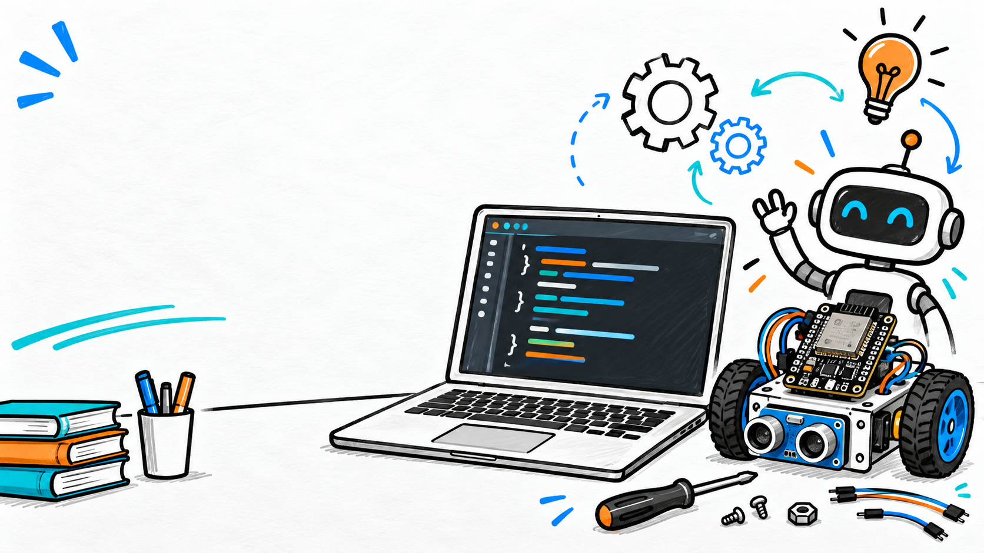
This lesson introduces students to C++ before ESP32 hardware. Students learn that programmers write source code, a compiler translates it, and the computer runs the result. The lesson is intentionally simple so the teacher can measure student confidence, typing accuracy, persistence, and ability to follow the edit, compile, run cycle.

Teacher Quick Start
Item | Details
Time | 60 to 75 minutes
Student setup | Windows laptop with VS Code, MSYS2, and g++ installed
Primary outcome | Students compile, run, edit, and explain a Hello World program
Collect | Skill check program or screenshot of terminal output
Best pacing | Slow demo first, then student work time, then short skill check

Learning Targets
- I can explain that C++ is a language for writing computer instructions.
- I can identify source code, compiler, program, compile, and run.
- I can find main, braces, cout, semicolons, comments, and return 0 in a simple program.
- I can compile and run a C++ program from the terminal.
- I can make a small code edit and run the program again.

Materials
- Student Laptop Setup Book
- Lesson 1 Student Workbook
- Lesson 1 Exercises
- Lesson 1 Instructor Answer Key
- Lesson 1 Video Series Script and Artwork Brief
- Student Starter Code folder

Lesson Flow
Time | Teacher Move | Student Move
0 to 5 | Ask: What makes a good instruction? | Give examples from school, games, cooking, or robotics.
5 to 15 | Explain source code, compiler, program, and the edit compile run cycle. | Fill in key words in the workbook.
15 to 25 | Live demo creating main.cpp and typing Hello World. | Watch first without typing unless directed.
25 to 40 | Guide students through typing, compiling, and running. | Create file, type code, compile, and run.
40 to 55 | Show edits, comments, and one intentional syntax error. | Change output, add comments, fix one error.
55 to 70 | Run skill check and circulate. | Build three-line output program.
70 to 75 | Exit question: What does the compiler do? | Answer in one or two sentences.

Mini Lesson Teacher Script
Use this as a natural script, not something to read word-for-word.
Today we are starting with plain C++ before using the ESP32. A robot controller is still a computer, and computers follow instructions exactly. The code we type is called source code. The computer does not run that source code directly. First, a tool called a compiler checks and translates it into a program. Then we run the program and see what it does.
The most important routine today is edit, save, compile, run, and fix. If something breaks, that is normal. The compiler is giving us feedback. Our job is to read the feedback, check the nearby code, and try again.

Starter Program
#include <iostream>

using namespace std;

int main() {
cout << "Hello, world!" << endl;
return 0;
}

Teacher Explanation Notes
Code Part | Say This
#include <iostream> | This gives our program tools for printing text.
using namespace std; | This keeps today's print command shorter.
int main() | This is where the program starts.
{ } | Braces hold the instructions inside main.
cout | This prints text to the terminal.
; | Many C++ statements end with a semicolon.
return 0; | This says the program finished successfully.

Guided Practice Commands
Compile:
g++ main.cpp -o hello.exe
Run:
.\hello.exe
Expected output:
Hello, world!

Student Skill Check
Students create a program that prints this exact output:
C++ Skill Check
I can edit source code.
I can compile and run a program.
The program must include a correct include line, main function, braces, at least one comment, three cout lines, semicolons, and return 0.

Assessment Rubric
Level | Evidence
Ready | Compiles, runs, output matches, and student can point to main, cout, braces, and semicolons.
Almost ready | Compiles after one or two small fixes; student understands the basic workflow.
Needs support | Student cannot yet compile and run without direct step-by-step help.

Common Problems
Problem | Teacher Response
g++ is not recognized | Check setup, PATH, and whether VS Code was reopened after setup.
No output appears | Make sure the student ran the .exe after compiling.
Old output appears | Save, compile again, then run again.
Missing semicolon | Look near the end of the previous statement.
Wrong folder | Open the correct lesson folder or move the terminal there.

Files in This Lesson Folder
- Lesson 1 Teacher Lesson Plan What Is Cpp.docx
- Lesson 1 Student Workbook What Is Cpp.docx
- Lesson 1 Exercises What Is Cpp.docx
- Lesson 1 Instructor Answer Key What Is Cpp.docx
- Lesson 1 Video Series Script and Artwork Brief.docx
- Artwork Samples folder
- Student Starter Code folder

Video Draft Status
Lesson 1 video draft created: C:\CppCourse\Level 1 Cpp Foundations\01 What Is Cpp\Video Draft\Lesson 1 What Is Cpp Draft Better Voice.mp4
Production package: C:\CppCourse\Level 1 Cpp Foundations\Exports\Lesson 1 Video Draft Package.zip
Review note: This is a review draft with neural narration and scene-card visuals. Use it to check pacing, wording, and visual clarity before recording or publishing a final version.

